Intelligence Report: Information Gathering (OSINT)
Course: NIAI NAVTTC — Certified Ethical Hacker (CEH) Course Assignment: Week 2 Lab Task
Important Notice: All tasks documented in this report were performed in an isolated virtual lab environment. The target, testasp.vulnweb.com, is a deliberately vulnerable application designed for safe practice. No real-world production networks or systems were targeted.
1. Executive Summary
- Target Domain: vulnweb.com
- Objective: Investigate a suspicious domain, analyze domain registration details, check for potential malicious activities, and provide actionable intelligence for an incident response team. Produce a structured intelligence report on a domain including ownership, DNS records, exposed services, and any suspicious indicators of compromise.

2. Domain Ownership (WHOIS Lookup)
Command used: whois vulnweb.com
- Registrar:
Gandi SAS
- Creation Date:
2010-06-14
- Contact Details:
Organization: Invicti Security Limited
Country: MT (Malta)
Email (Privacy Protected): e7c92ba29faca2e997bfc9ce58d5c661-57148476@contact.gandi.net
Abuse Contact: abuse@support.gandi.net
- Name Servers:
NS-105-A.GANDI.NET
NS-11-B.GANDI.NET
NS-140-C.GANDI.NET

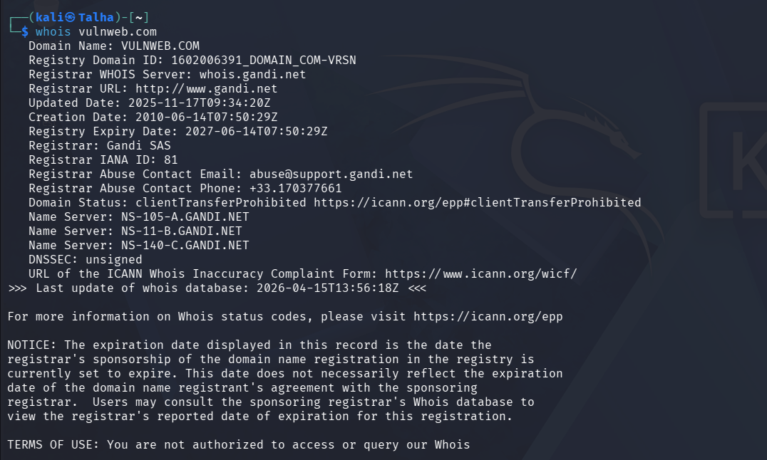
3. Associated IP Addresses (DNS Enumeration)
Commands used: nslookup vulnweb.com and host vulnweb.com
- Primary IP Address(es): 44.228.249.3
- Mail Servers (MX Records): aspmx.l.google.com
  - alt1.aspmx.l.google.com
  - alt2.aspmx.l.google.com
  - alt3.aspmx.l.google.com
  - alt4.aspmx.l.google.com
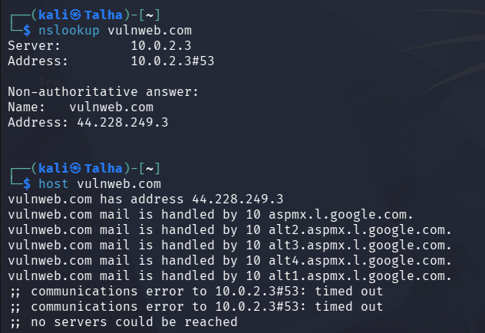
4. Emails and Subdomains (theHarvester)
Command used: theHarvester -d vulnweb.com -b duckduckgo,yahoo,crtsh (Note: Alternative search engines and certificate logs were utilized due to the deprecation of the Google search module in the current tool version).
- Discovered Emails: None found.
- Discovered Subdomains (Hosts):
  - 25252Ftestphp.vulnweb.com
  - 3dTestphp.vulnweb.com
  - 3dtestasp.vulnweb.com
  - SQL-Injection-Assessment-testphp.vulnweb.com
  - Test.vulnweb.com
  - Testphp.vulnweb.com
  - php.vulnweb.com
  - rest.vulnweb.com
  - scan-report-testphp.vulnweb.com
  - test.vulnweb.com
  - testasp.vulnweb.com
  - testaspnet.vulnweb.com
  - testhtml5.vulnweb.com
  - testphp.vulnweb.com
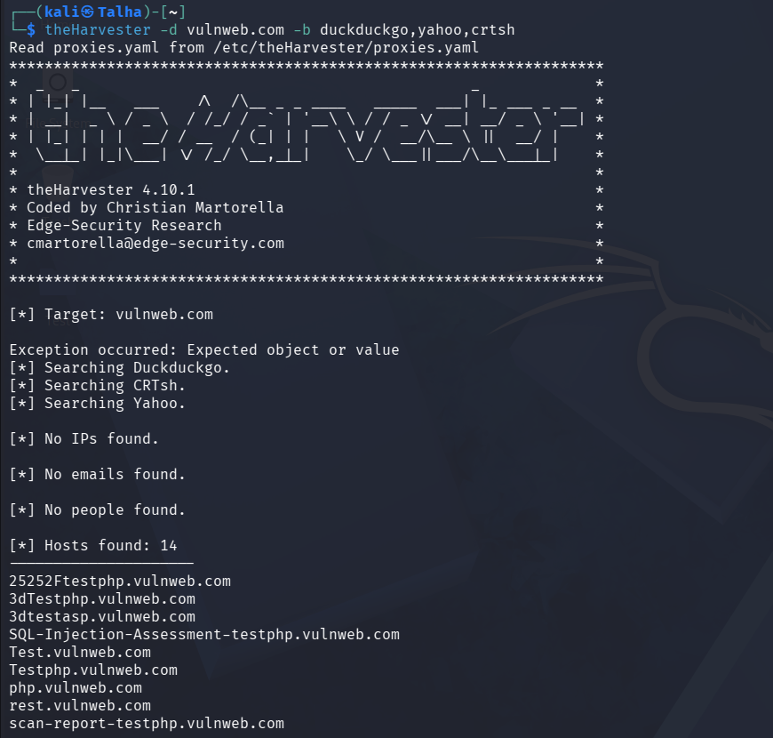

5. Exposed Services (Shodan)
Method used: Search via shodan.io using the domain name or its IP address.
- Exposed Ports & Services: [List open ports and visible services, e.g., 22, 80, 443]
In my case vulnweb is dead domain so I tested on tesla.com for just showing the results
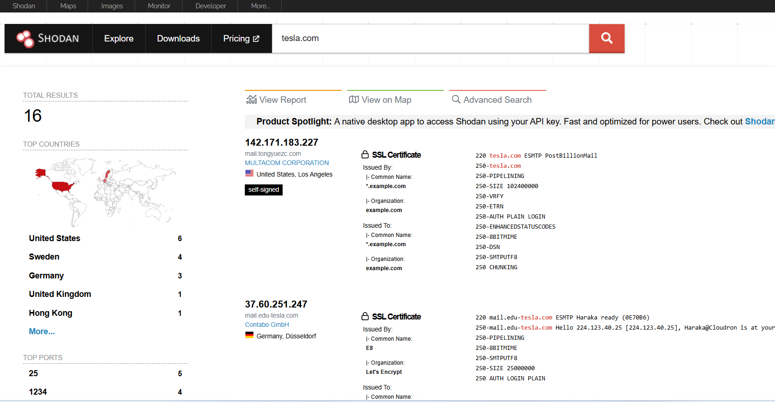

6. Indexed Pages (Google Dorks)
Queries used in Google browser: site:vulnweb.com and intitle:index.of vulnweb.com.
- Findings: The site:vulnweb.com query successfully returned multiple indexed pages across various subdomains (such as testphp, testasp, and testhtml5). The indexed results revealed multiple potential attack surfaces, including login portals (e.g., login.php), guestbook submissions, search functions, and product category pages. These pages indicate dynamic content backed by databases.
- The intitle:index.of vulnweb.com query did not reveal any exposed, misconfigured root directories or file shares containing sensitive documents directly on the target domain.
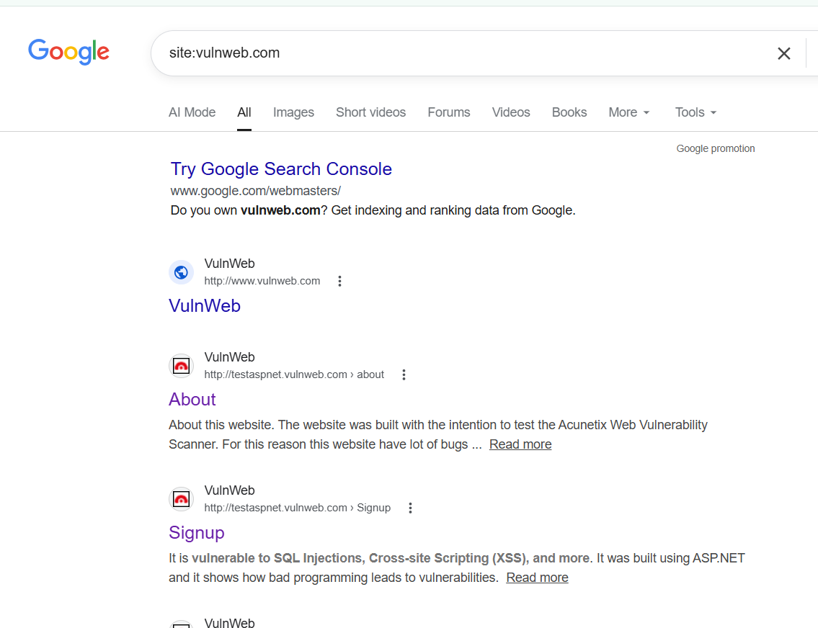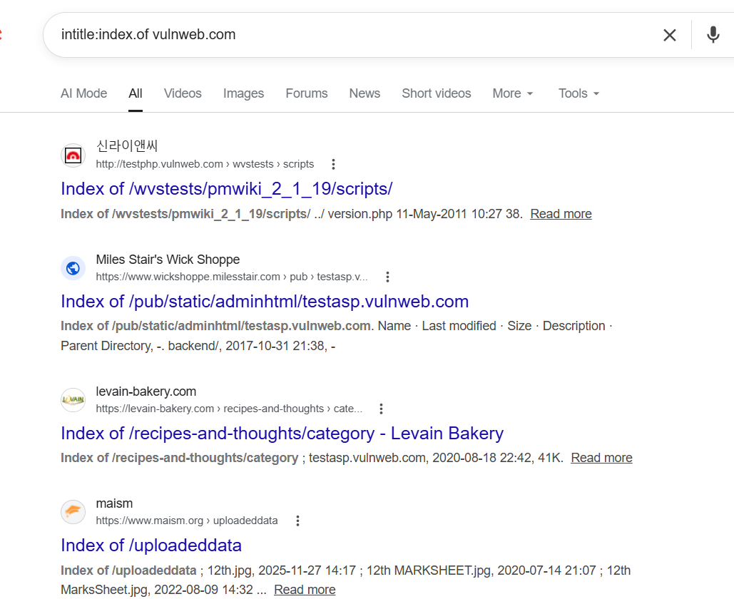

7. Suspicious Indicators & Conclusion
- Suspicious Indicators Found:
The domain hosts numerous subdomains with naming conventions that explicitly suggest testing and vulnerability environments (e.g., testphp, testasp, SQL-Injection-Assessment).
Google Dorking revealed exposed login portals, guestbook submission forms, and other dynamic entry points that are typically targeted in web application attacks.
The WHOIS record shows the domain is owned by Invicti Security Limited, a known vendor of automated web application security testing tools.
Actionable Intelligence:
Based on the OSINT gathering, vulnweb.com is not a malicious threat actor infrastructure, but rather a deliberately vulnerable testing ground used for cybersecurity training and tool calibration. For an incident response team, any network traffic connecting to this domain likely indicates internal security personnel or students conducting authorized testing and practice, rather than an active compromise or malware communicating with a Command and Control (C2) server.

